

Compensation and Pension Record Interchange (CAPRI)

(CAPRI GUI v. DVBA_27_190_04)

Release Notes

Patch DVBA*2.7*190

May 2015

Department of Veterans Affairs

Office of Enterprise Development

Preface

Purpose of the Release Notes

The Release Notes document describes the enhancements and/or defects addressed in Patch DVBA*2.7*190.

Reference Numbering System

This document uses a numbering system to organize its topics into sections and show the reader how these topics relate to each other. For example, section 1.3 means this is the main topic for the third section of Chapter 1. If there were two subsections to this topic, they would be numbered 1.3.1 and 1.3.2. A section numbered 2.3.5.4.7 would be the seventh subsection of the fourth subsection of the fifth subsection of the third topic of Chapter 2. This numbering system tool allows the reader to more easily follow the logic of sections that contain several subsections.

Table of Contents

1 Overview 1

2 Customer – Veterans Health Administration (VHA) 1

2.1 Enhancements 1

2.1.1 Acceptable Clinical Evidence (ACE) Initiative – C&P Worksheets Tab 1

2.1.2 Enable mouse roller wheel within templates– C&P Worksheets Tab 2

2.1.3 Update default option for Cancel by MAS (VHA) or Cancel by Regional Office (VBA) – C&P Exam Tab 3

2.1.4 CAPRI Contract Referral (CCR) option – Add functionality to not allow user to proceed until “Reassign” to vendor is chosen 4

2.1.5 Add Claim Type, Special Considerations, and Insufficient field values to the comments section – C&P Exam Tab 5

3 Customer – Veterans Health Administration (VHA) and Veterans Benefits Administration (VBA) 6

3.1 Enhancements 6

3.1.1 Updates to the Clinical Documents Tab 6

3.1.2 Add “Electronic Claim Folder Available?” on the Add New C&P Exam and View C&P Exam Screens – C&P Exam Tab 9

3.1.3 Modify the Pending C&P Exams report to display Veteran’s Cell Phone number and Email Address – File|Reports|Pending C&P Exams 11

4 Customer – Veterans Benefits Administration (VBA) 13

4.1 Defects without remedy ticket 13

4.1.1 Request Status by Date Range report not displaying “Station” information 13

5 Customer – Veterans Health Administration (VHA) 13

5.1 Defects without remedy ticket 13

5.1.1 Rapid growth of ^DVB global 13

6 Customer – Veterans Benefits Administration (VBA) 13

6.1 Enhancements 13

6.1.1 Updates to Address Verification Screen – C&P Exam tab/Add a New Request button/Address Verification screen 13

6.1.2 Allow user modifications to 2507 Exam Cancellation and Exam Insufficient reasons 15

7 Software and Documentation Retrieval 20

7.1 VistA Patch DVBA*2.7*190 20

7.2 CAPRI GUI v190 Client Software & User Documentation 20

7.3 Related Documents 21

# Overview

The main purpose of this patch is to release a new version of the Compensation & Pension Record Interchange (CAPRI) Graphical User Interface (GUI) that includes defect fixes and enhancements to the user interface to support user interface modifications.

CAPRI GUI v190 and patch (DVBA*2.7*190) provide defect fixes and enhancements for the CAPRI GUI and the Automated Medical Information Exchange (AMIE) package.

The information contained in this document is not intended to replace the CAPRI GUI User Manual. The software defects and enhancements are briefly discussed so that readers are aware of high level functional changes. The CAPRI GUI User Manual should be used to obtain detailed information regarding specific functionality.

# Customer – Veterans Health Administration (VHA)

## Enhancements

### Acceptable Clinical Evidence (ACE) Initiative – C&P Worksheets Tab

End users will have the ability to indicate that Acceptable Clinical Evidence (ACE) was used.

Once a user is on the template screen and has completed all required sections of the template(s) and the “Done” button is chosen, a dialog box will be displayed asking the user “**Was this report performed using ACE?**” The user will choose either Yes or No and then be taken to the final report preview window to continue the normal process of signing templates. The default value for this question is “**NO**”.

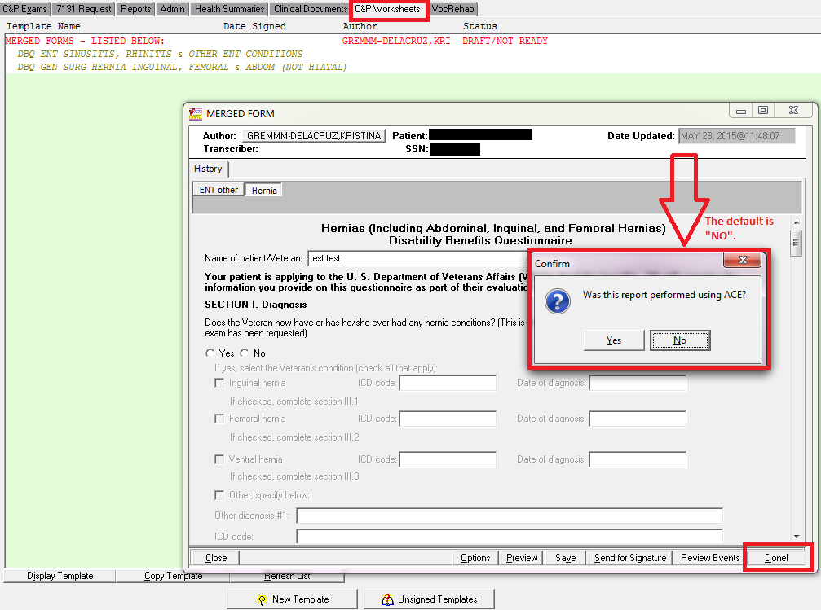

**\*\*Please Note:** This response will “not” appear on the final report, the Yes/No value is being stored in the CAPRI Template File (396.17), Acceptable Clinical Evidence field (#1) to accommodate CDW reporting.

### Enable mouse roller wheel within templates– C&P Worksheets Tab

CAPRI has been modified to allow mouse roller wheel functionality within the CAPRI Templates.

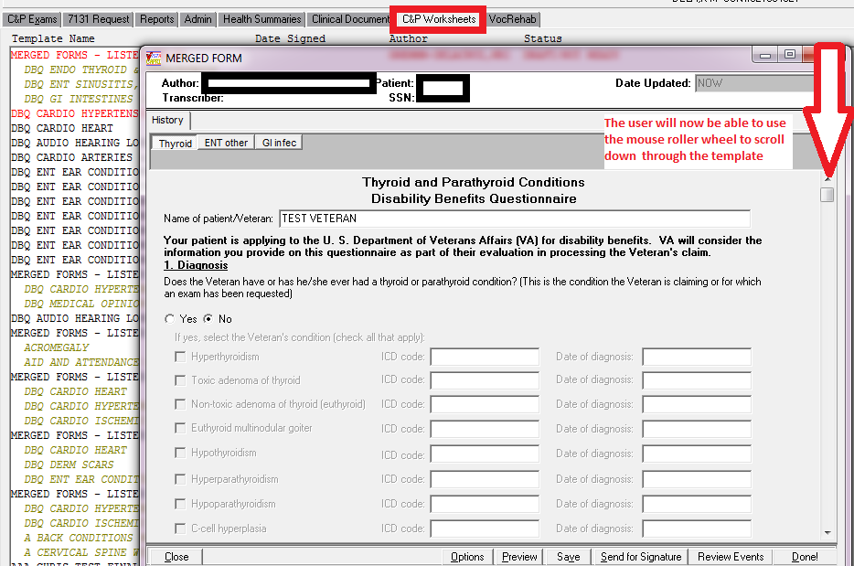

The mouse roller wheel functionality has also been added to the C&P Exam Tab (**Add a New C&P Exam, View C&P Exam, and Exam Details windows**).

### Update default option for Cancel by MAS (VHA) or Cancel by Regional Office (VBA) – C&P Exam Tab

When cancelling a C&P Exam(s) the default was Cancel by Regional Office. CAPRI has been modified to default to **Cancel by MAS** if a user is logged into **their local VistA system**. If a **remote user** (**CLAIMS**) cancels an exam(s), the default will be **Cancel by Regional Office**.

**LOCAL User (Local VistA system) – Cancel by MAS is enabled and Cancel by Regional Office is disabled**

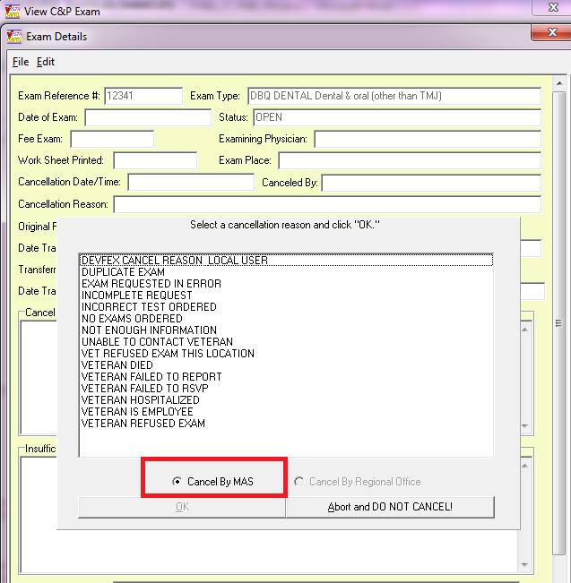

**REMOTE User (CLAIMS) – Cancel by Regional Office is enabled and Cancel by MAS is disabled**

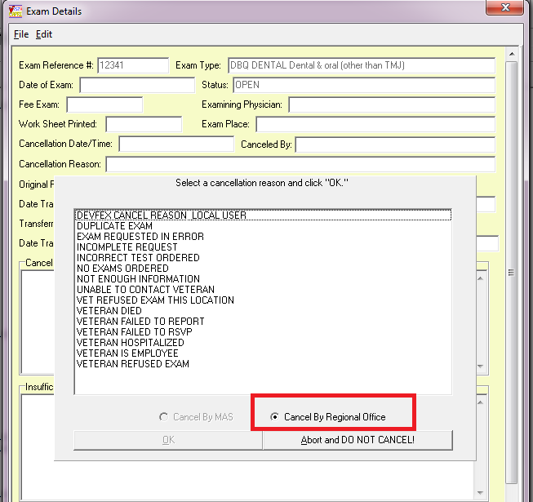

### CAPRI Contract Referral (CCR) option – Add functionality to not allow user to proceed until “Reassign” to vendor is chosen

**CAPRI Contract Referral (CCR)** option has been modified to not allow the user to proceed, **after marking an exam insufficient**, until they choose “**reassign to vendor**” button. If the user tries to close the window, either by choosing “**Close Window**” button or “**X**”, a message will **pop up** to the user stating “**You must reassign to vendor before closing**”.

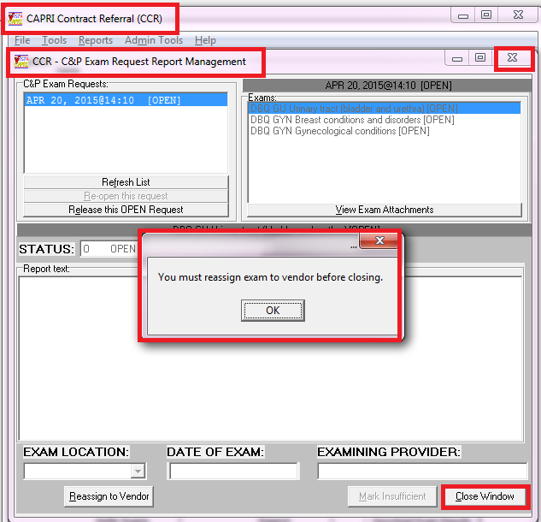

### Add Claim Type, Special Considerations, and Insufficient field values to the comments section – C&P Exam Tab

Claim Type, Special Considerations and Insufficient responses have been added to the "Comments" section of the C&P Exam|View C&P Exam window.

**Example:**

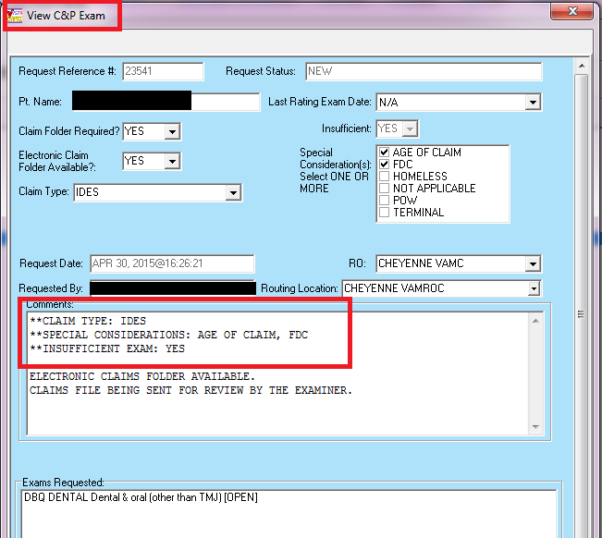

# Customer – Veterans Health Administration (VHA) and Veterans Benefits Administration (VBA)

## Enhancements

### Updates to the Clinical Documents Tab

The **Find/Search functionality** currently available for the Notes tab and Discharge Summaries tab has been added to the **Consults tab, Imaging tab, Nutritional Assessment tab, and Procedures tab**.

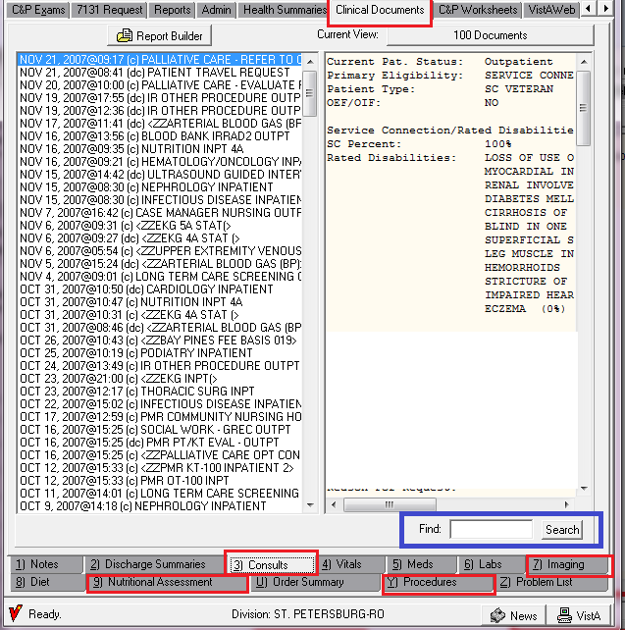

All tabs within the Clinical Documents tab have been modified to have the ability to right click and search the results with “find” within the display window on the right side.

To search for a word within the display window on the right perform the following:

1. Choose a report to search
2. **Right click** within the report window on the **right side**
3. Click on **“Find”**

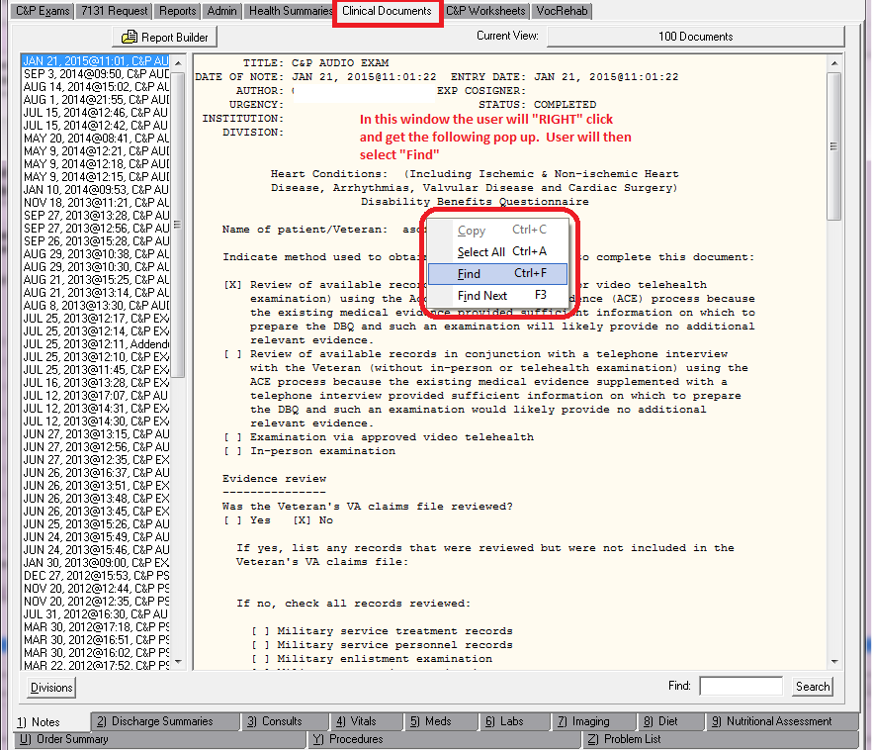

1. Enter the word to be searched for in the **“Find What”** field

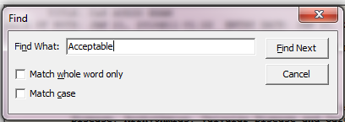

1. Click **“Find Next”** button and the word being searched for will be highlighted

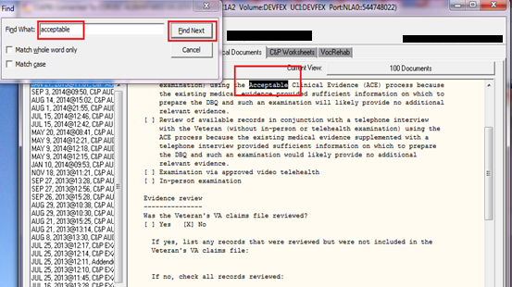

1. Continue to click **“Find Next”** in the **Find Window** to search for the word again. Once the search has been exhausted the message of “**Search reached end of text.**” will be displayed to the user.

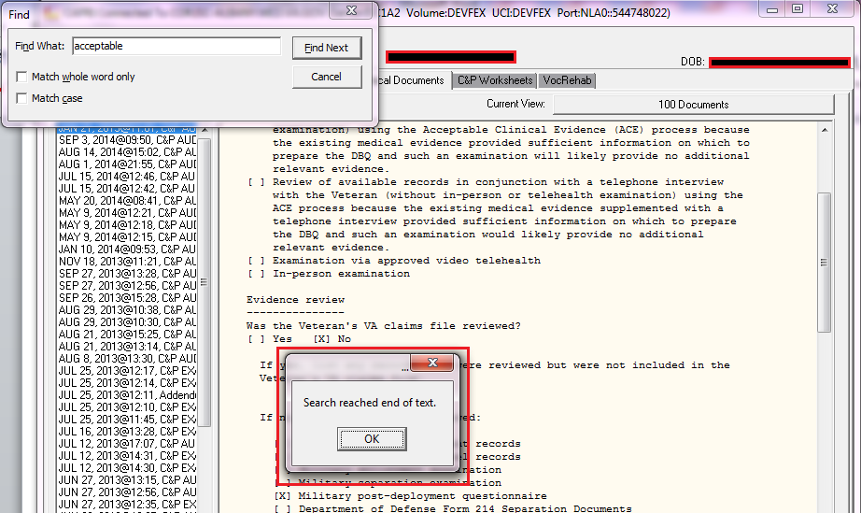

1. Click **‘OK”** button to close message and “Cancel” to close the **Find** window.

### Add “Electronic Claim Folder Available?” on the Add New C&P Exam and View C&P Exam Screens – C&P Exam Tab

The **Add New C&P Exam**, **Add New Insufficient Exam, and View C&P Exam** screens have been modified to contain **“Electronic Claim Folder Available?”**

The “**Electronic Claim Folder Available?**” field will have a default value of blank**.** The field is **required** and will only allow selection of **YES or NO** values.

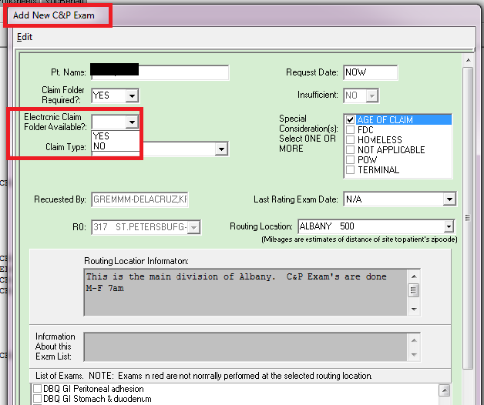

If **Electronic Claim Folder Available?** is **not** chosen a message will be displayed to the user “**Please select whether Electronic Claim Folder Available is required.**” upon sending a new exam request.

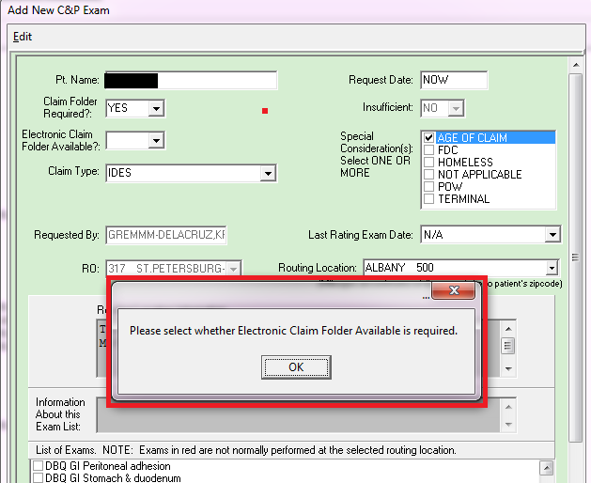

If the value selected is “**YES**”, the **View C&P Exam** screen will display **“ELECTRONIC CLAIMS FOLDER AVAILABLE.”** in the **Comments** section. If value of “**NO**” was selected, nothing will be displayed in the **Comments** section regarding the Electronic Claims Folder Available.

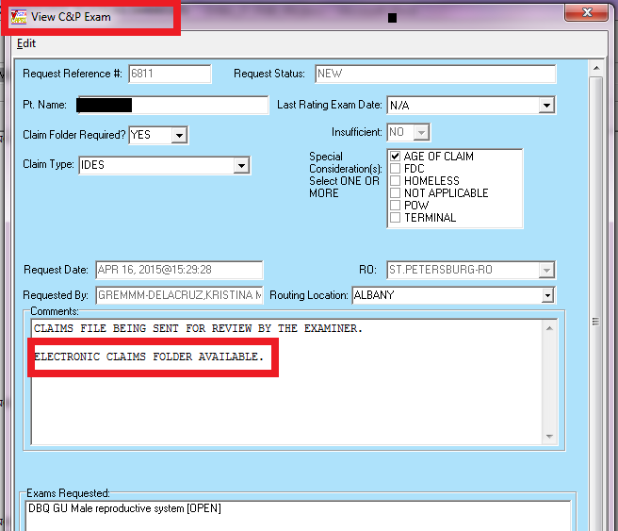

### Modify the Pending C&P Exams report to display Veteran’s Cell Phone number and Email Address – File|Reports|Pending C&P Exams

The **“Pending C&P Exams”** report, both Plain Text and CSV Comma Delimited Export, has been modified to display a veteran’s Cell Phone number and Email address, if available. If the veteran’s file does not have either a Cell Phone or Email Address the field on the report will be left blank.

**Example: Plain text report format**

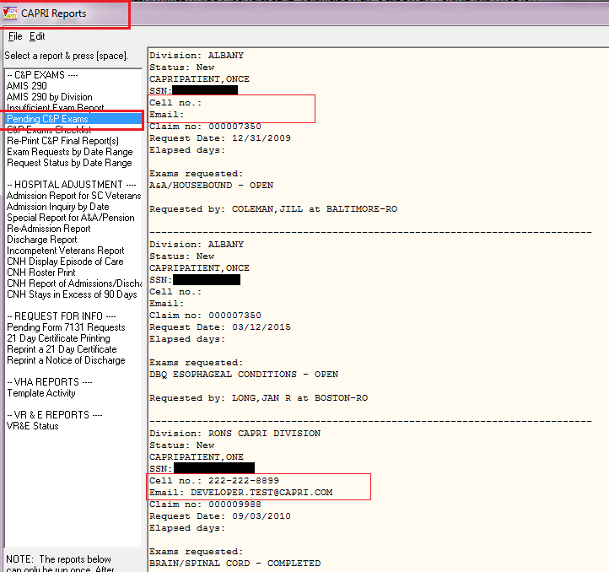

**Example: CSV Comma Delimited Export report format (Excel component)**

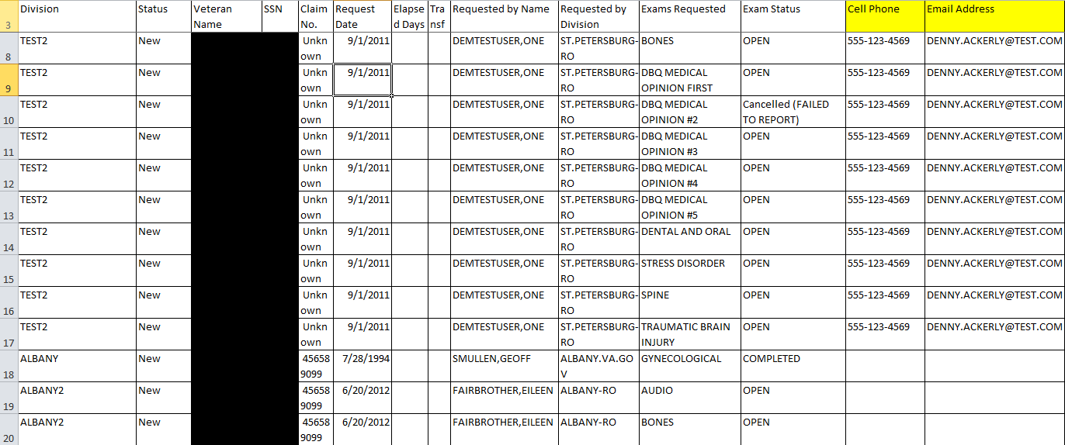

# Customer – Veterans Benefits Administration (VBA)

## Defects without remedy ticket

### Request Status by Date Range report not displaying “Station” information

**Request Status by Date Range** report has been modified to display the **“Station”** information on both the plain text display and CSV Comma Delimited Export (excel component).

# Customer – Veterans Health Administration (VHA)

## Defects without remedy ticket

### Rapid growth of ^DVB global

CAPRI 186 introduced a defect where the draft copies of templates are not being deleted when the template is completed causing rapid growth of the ^DVB global.

The code that was mistakenly deleted in DVBA*2.7*186 has been added back in and will now delete draft entries once the template(s) are completed.

# Customer – Veterans Benefits Administration (VBA)

## Enhancements

### Updates to Address Verification Screen – C&P Exam tab/Add a New Request button/Address Verification screen

The Address Verification screen has been modified to display and allow entry of Cell Phone and Email address.

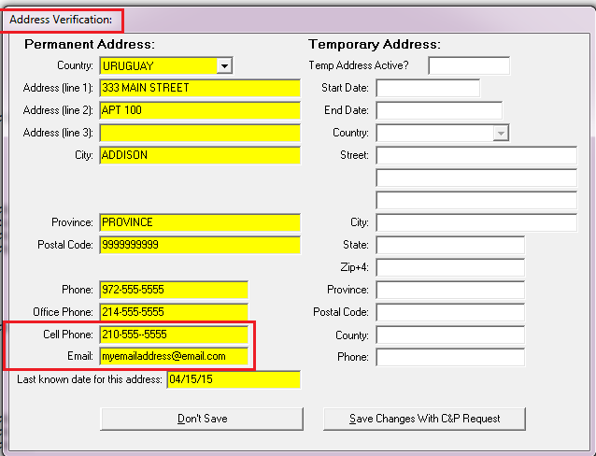

Once the “**Save Changes With C&P Request**” button has been chosen the edits will be displayed in the “Comments” section of the C&P Exam upon sending the request.

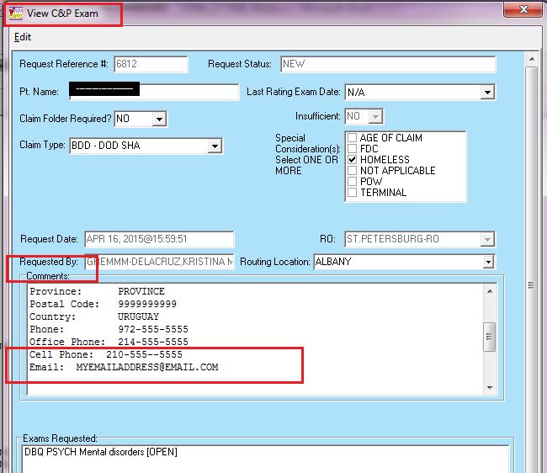

### Allow user modifications to 2507 Exam Cancellation and Exam Insufficient reasons

CAPRI has been enhanced to provide two new menu options “**Manage Exam Cancellation Reasons”** and **“Manage Exam Insufficient Reasons”**, which will allow a user to add/inactivate/reactivate 2507 Cancellation Reasons and/or 2507 Insufficient Reasons. These options will be available from the **HELP** menu.

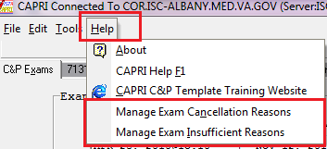

These options will only be available to **CAPRI-Remote (national) users** who are assigned security keys “**DVBA CAPRI EXAMCANC**” and “**DVBA CAPRI EXAMINSUFF**”.

**SECURITY KEY ALLOCATION:**

**DVBA CAPRI EXAMCANC** – must be assigned to a user that will need access to the **“Manage Exam Cancellation Reasons”** option.

**DVBA CAPRI EXAMINSUFF –** must be assigned to a user that will need access to the **“Manage Exam Insufficient Reasons”** option.

**MANAGE EXAM CANCELLATION REASONS** option functionality:

1. From the **HELP** menu choose “**Manage Exam Cancellation Reasons**” option
2. The “Manage Exam Cancellation Reasons” window will be displayed

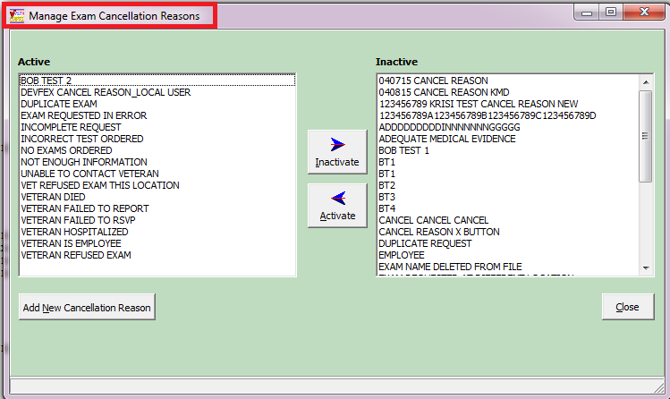

1. To **Inactivate** an Active reason, choose thereason in the **Active list** and click the “**Inactivate**” button. This will move the active reason chosen to the **Inactive list** column.

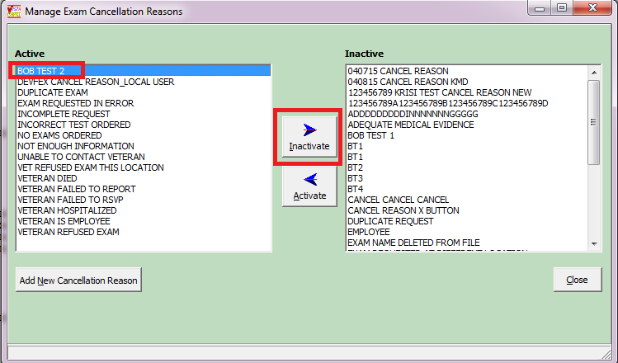

1. To **Activate** an Inactive reason, choose the reason from the **Inactive list** and click the “**Activate**” button. This will move the inactive reason chosen to the **Active list** column.

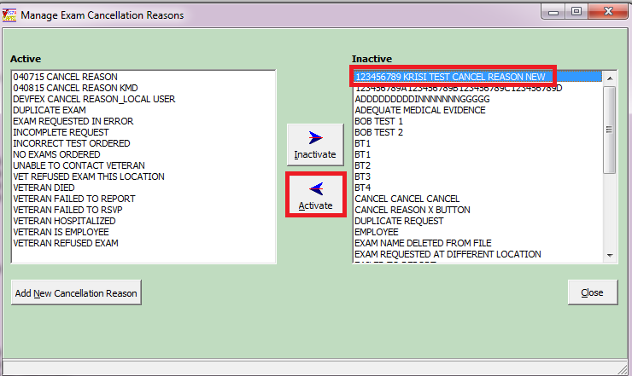

1. To add a cancellation reason, click the “**Add New Cancellation Reason**” button

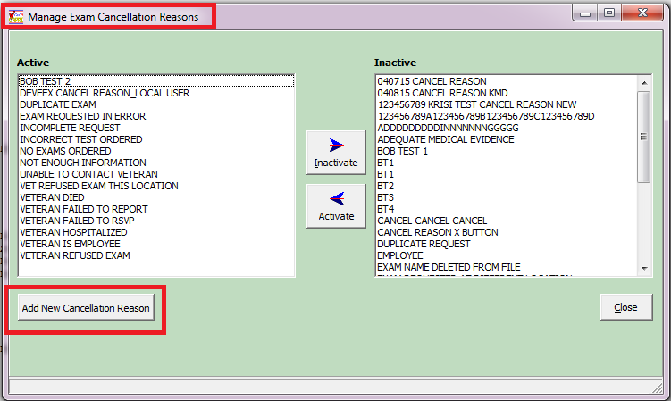

1. Enter the new cancellation reason in the text field. Cancellation reason must be **3-40** characters in length.

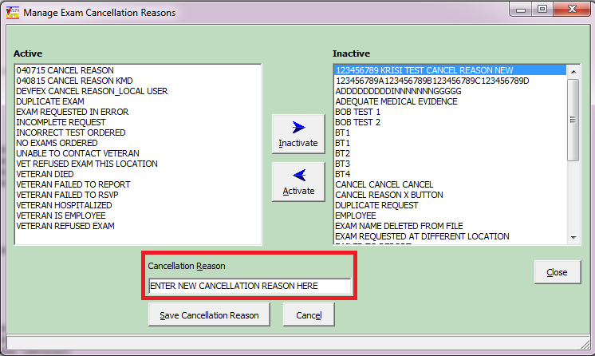

1. To **save** the cancellation reason just entered, click “**Save Cancellation Reason**” button. Once saved, the reason entered will be automatically added to the “**Active**” list column.
2. If you **do not** want to **save** the cancellation reason click “**Cancel**” button. Reason will “not” be added to either the Active or Inactive list columns.
3. To **EXIT** the “**Manage Exam Cancellation Reasons**” window click the “**Close**” button or “**X**” to close the window.

**MANAGE EXAM INSUFFICIENT REASONS** option functionality:

1. From the **HELP** menu choose “**Manage Exam Insufficient Reasons**” option
2. The “Manage Exam Insufficient Reasons” window will be displayed

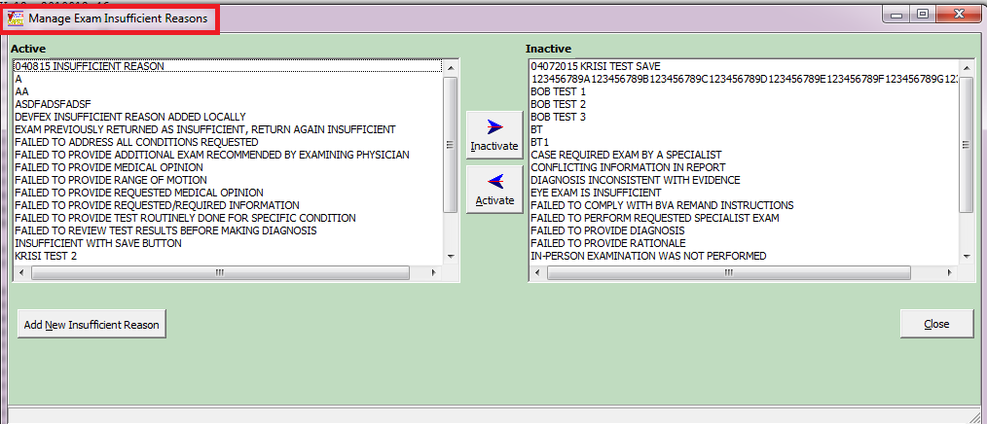

1. To **Inactivate** an Active reason, choose thereason in the **Active list** and click the “**Inactivate**” button. This will move the active reason chosen to the **Inactive list** column.

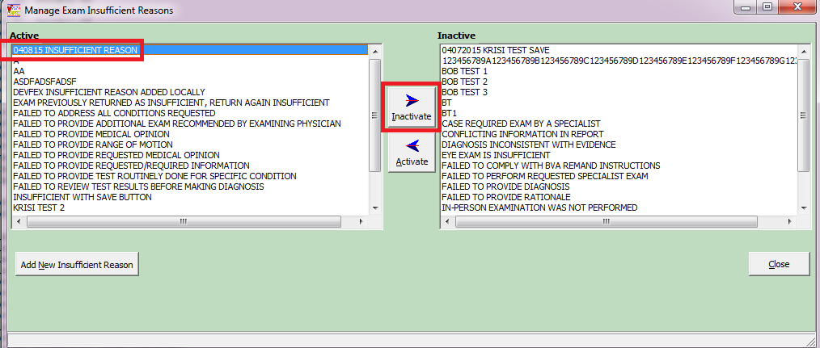

1. To **Activate** an Inactive reason, choose the reason from the **Inactive list** and click the “**Activate**” button. This will move the inactive reason chosen to the **Active list** column.

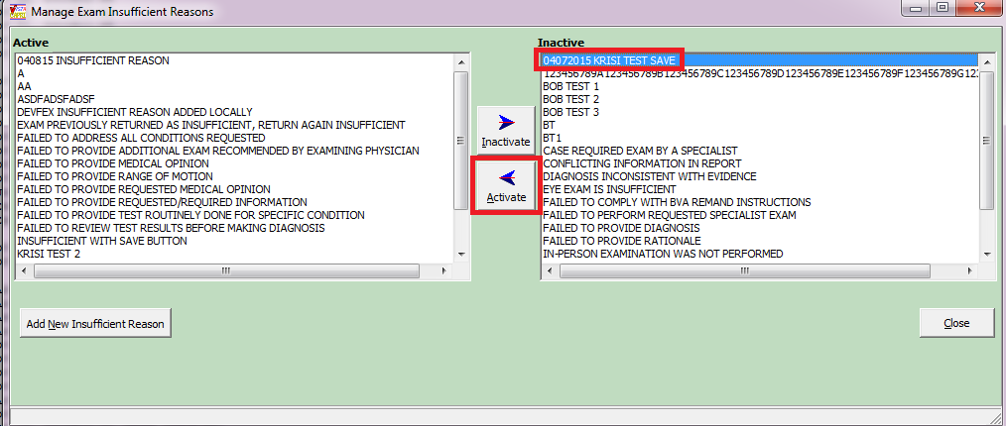

1. To add an insufficient reason, click the “**Add New Insufficient Reason**” button

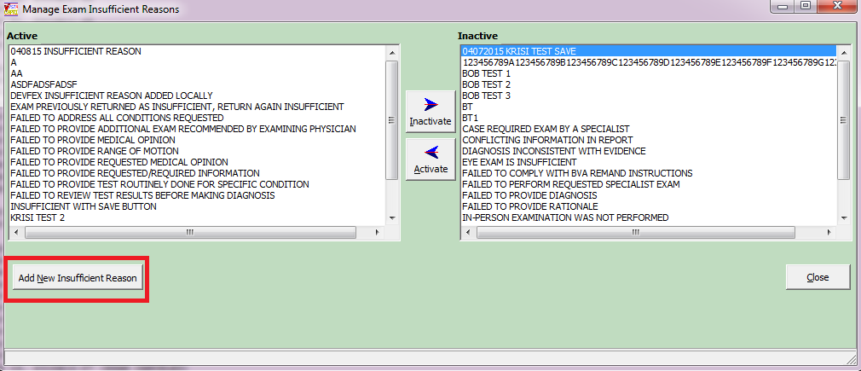

1. Enter the new insufficient reason in the text field. Insufficient reason must be **1-75** characters in length.

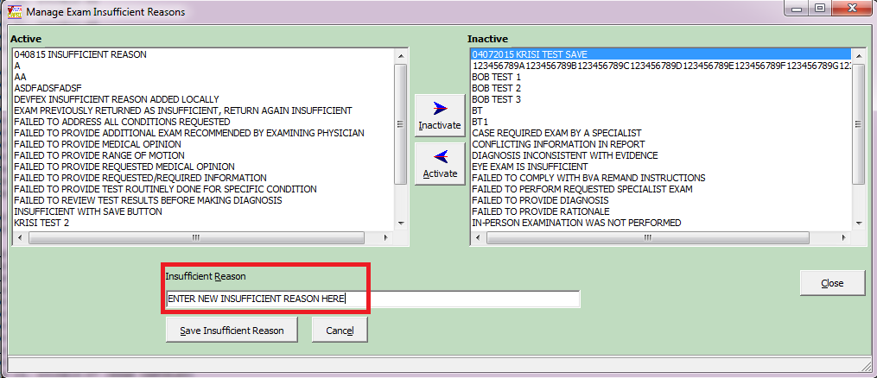

1. To **save** the insufficient reason just entered, click “**Save Insufficient Reason**” button. Once saved, the reason entered will be automatically added to the “**Active**” list column.
2. If you **do not** want to **save** the insufficient reason click “**Cancel**” button. Reason will “not” be added to either the Active or Inactive list columns.
3. To **EXIT** the “**Manage Exam Insufficient Reasons**” window click the “**Close**” button or “**X**” to close the window.

# Software and Documentation Retrieval

## VistA Patch DVBA*2.7*190

The VistA server software is being distributed as a PackMan patch message through the National Patch Module (NPM). The KIDS build for this patch is DVBA*2.7*190.

## CAPRI GUI v190 Client Software & User Documentation

The CAPRI GUI v190 client software is being distributed as executable CAPRI.exe contained in the zip file [**DVBA_27_P190_04.ZIP**]. The installed executable for this patch is client version 190.04 with a size of 16.4 MB.

The CAPRI GUI v190 client software and documentation for this patch may be retrieved directly using FTP. The preferred method is to FTP the files from:

download.vista.med.va.gov

This transmits the files from the first available FTP server. Sites may also elect to retrieve software directly from a specific server as follows:

|  |  |  |
| --- | --- | --- |
| OI&T Field Office | FTP Address | Directory |
| Albany | [ftp.fo-albany.med.va.gov](ftp://ftp.fo-albany.med.va.gov) | [anonymous.software] |
| Hines | [ftp.fo-hines.med.va.gov](ftp://ftp.fo-hines.med.va.gov) | [anonymous.software] |
| Salt Lake City | [ftp.fo-slc.med.va.gov](ftp://ftp.fo-slc.med.va.gov) | [anonymous.software] |

The following files will be available:

|  |  |  |
| --- | --- | --- |
| File Name | Retrieval Format | Contents |
| DVBA_27_P190_04.zip | Binary | File(s) indented below:   * CAPRI.exe - CAPRI v190 executable * VACAPRIVVA.dll – Virtual VA dynamically linked library * CAPRI_Help.chm * CAPRI.map - CAPRI error map * CAPRISession.r2w - Reflections session configuration * ssh_config - Secure Shell configuration * CAPRI_GUI_ISG.doc - CAPRI GUI Installation Supplemental Guide * Libeay32.dll - VLER /DAS dynamically linked library * Ssleay32.dll - VLER /DAS dynamically linked library * QPDF.exe – Support PDF compression and Linearization * QPDF13.dll – Support PDF compression and Linearization * LILBGCC_S_DW2-1.dll - Support PDF compression and Linearization * LIBSTCD++6.dll - Support PDF compression and Linearization |
| DVBA_27_P190_RN.PDF | Binary | Patch Release Notes (This document) |
| DVBA_27_P190_UM.PDF | Binary | Updated CAPRI GUI User Manual |
| CAPRI_SYSADMINTECH GUIDE_DVBA_27_TM.PDF | Binary | Updated CAPRI System Administration  And Technical Guide |

## Related Documents

The VA (Software) Documentation Library (VDL) web site will also contain the DVBA*2.7*190 Release Notes and updated CAPRI GUI User Manual. This website is usually updated within 1-3 days of the patch release date.

The VDL web address for CAPRI documentation is: <http://www.va.gov/vdl/application.asp?appid=133>